Your support secures a place for fiber art in the Bay Area.

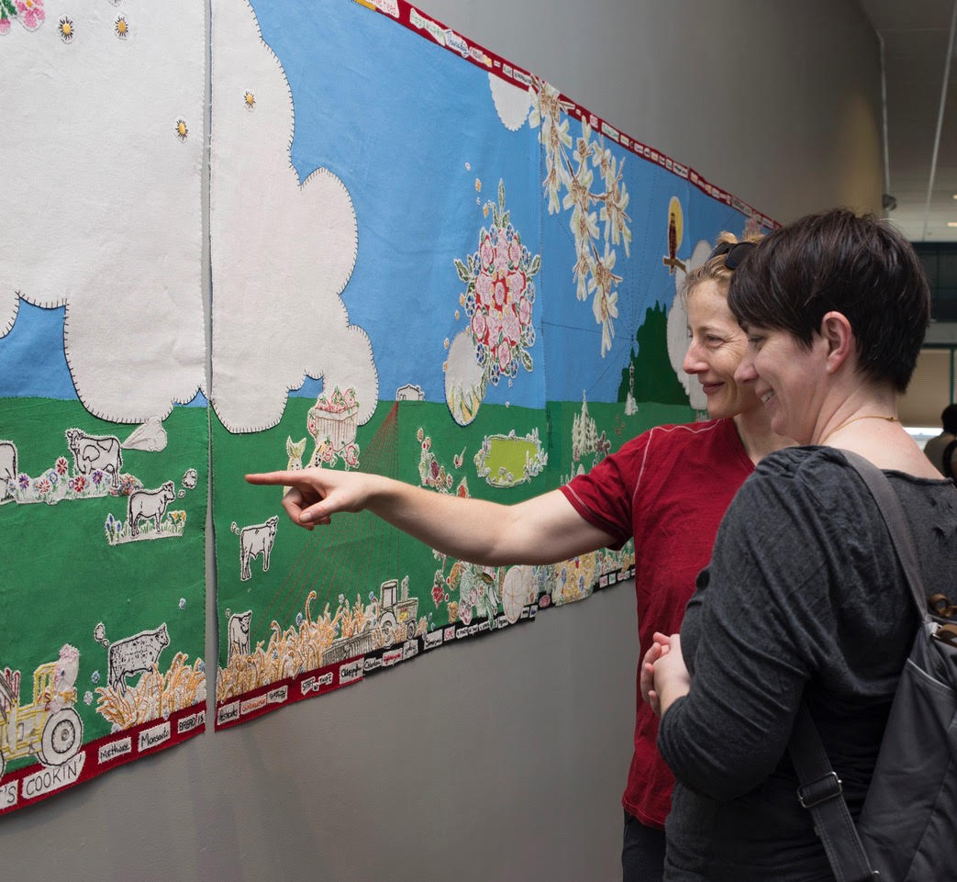

What is a quilt or a textile? How would you describe fiber art?

For many of you, the answer is easy. Perhaps you are an artist or maker. You may collect art from this particular medium or you simply enjoy looking at textiles and fiber art like I do.

Whatever your response, the San Jose Museum of Quilts & Textiles is the place to explore these answers. As Director of the Museum, I know that many visitors come frequently and are long-time supporters. However, I am especially pleased to notice an increasing number of Museum guests who are seeing and learning about quilts, textiles and fiber art for the first time.
Visitors discussing Maggy Rozycki Hiltner’s Vantage Point
SJMQT, 2018

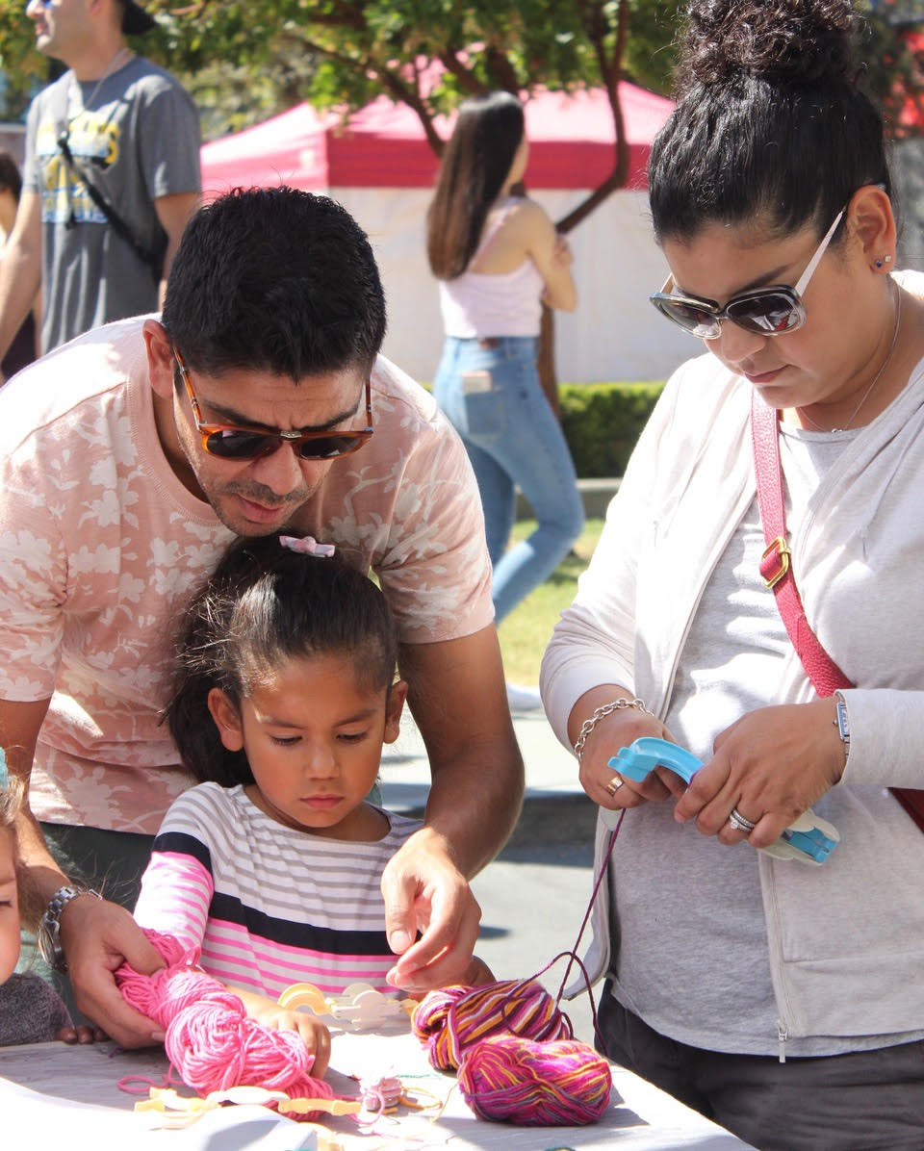
As a visitor, you learn how the Museum celebrates the art, creators, and history of quilts and textiles. You view exhibitions with innovative fiber and quilt art as well as historic quilts and textiles, and discover textile traditions from world cultures. You see works from the Permanent Collection that honor textile traditions, and you learn the importance of documenting and preserving these art works for future generations. You meet artists, learn about their creative process, and leave inspired.
Family friendly art activities at a recent Family Community Day

I hope you will make a donation today so that the Museum can continue to expand the world of quilts and fiber arts for new friends and old.

Everything the Museum offers – exhibitions, the Permanent Collection, reaching out to the community, and supporting artists – influences the lives of artists, visitors & the community.

Meet artist Susan Else, whose circus-themed exhibition Without a Net premiered in January 2018.
Susan says:

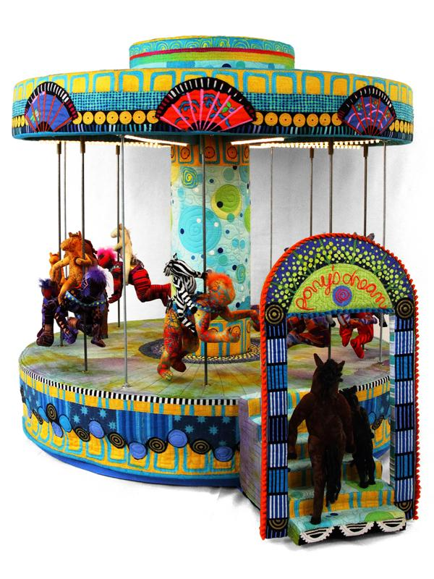
This museum has been important to me personally and to the development of my art. In the long-term, it has meant that there was a museum where I could see work in the medium I was pursuing. And as a quilt artist, that is very important, because there is no guarantee you will see work in our medium anywhere else. The other thing I appreciate is that every time I come to the museum there is something different to see; the exhibitions incorporate a variety of mediums, from historical textiles to cutting-edge contemporary work.
Susan Else, When Ponies Dream

With your support, the Museum can continue to be a place to exhibit fiber art.

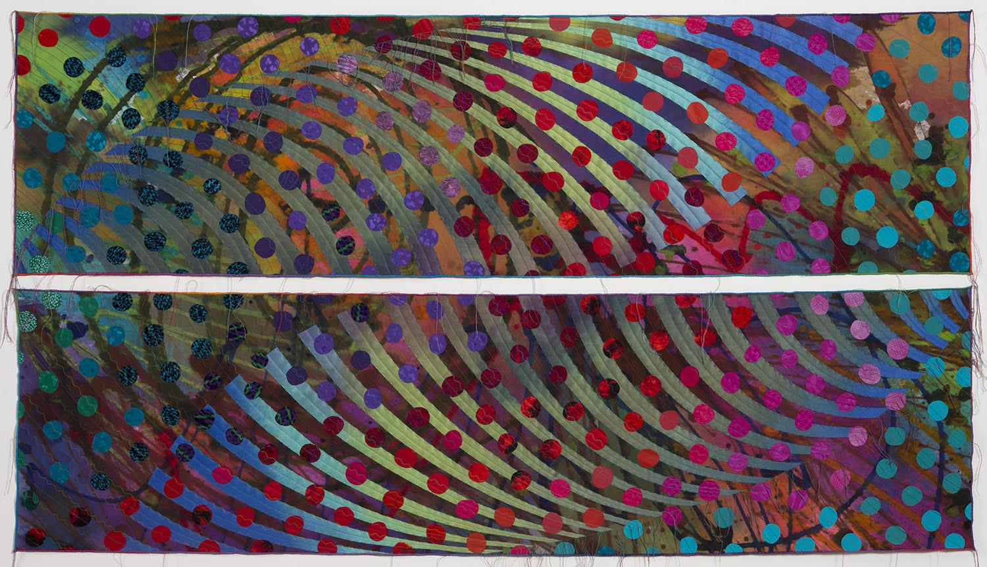
Besides exhibitions, the Museum plays an important role building an excellent Permanent Collection of historic quilts, art quilts, fiber art and textiles. In 2017, the Museum received an extraordinary gift of 87 art quilts from Marvin Fletcher and his late wife Hilary, known as the Marbaum Collection. This donation enhances the Museum’s Permanent Collection to an extraordinary degree, and establishes it as one of the leading institutions in collecting, documenting and preserving the art form. Through Hilary and Marvin’s generosity and foresight, the Museum will have many opportunities to inspire today’s visitors and provide an enduring legacy for future generations.
Sue Benner, Sink or Swim #21 & #22, 1995
The Marbaum Collection: Gift of Hilary and Marvin Fletcher

Marvin Fletcher explains why he and Hilary chose the Museum:

I have admired the San Jose Museum of Quilts & Textiles for many years. Every time Hilary and I visited the Bay Area, we made it a destination and we were never disappointed. I think textiles, especially quilts, are an underestimated art form and I think the SJMQT does a wonderful job in promoting the art form. We especially liked the well-designed exhibition spaces, which gives one plenty of room to admire and appreciate the artwork. The well-equipped museum storage area was one of the aspects that gave me confidence to donate our quilts. I continue to support SJMQT because it is an important member of the community. It is one of the finest museums of its type in the world. It was the first choice when I was thinking of donating many of the quilts Hilary and I accumulated over the years.

Please consider donating to keep this dynamic arts institution protected for the whole community to enjoy.

In addition to building a Permanent Collection, you may have noticed that the Museum is reaching out to the community through unique partnerships. Perhaps you came to see the groundbreaking exhibition Guns: Loaded Conversations. I was impressed to see first-time visitors and long-time supporters exploring these powerful works of art. Visitors saw and felt the ability of fiber art to communicate thoughts on important social issues. I am also proud to tell you that the Museum collaborated with the San Jose Police Department and Police Foundation to raise funds and collect quilts for a gun buy-back at the police station.

With this exhibition, related programs, and the initiative Cash + Quilts for Guns, the Museum addressed a critical need. Our programs made a positive change in the community, raised awareness of the complex issue of guns in this country, and provided a safe place for discussion and reflection.
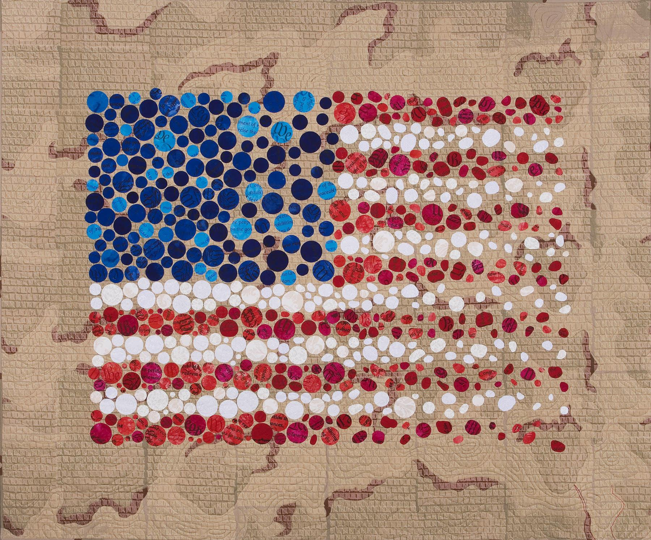
Charlotte Bird, Dulce et Decorum
I knew we had succeeded in our goals when a visitor wrote in our guest book:

“Thank you for having the courage to do this exhibition and taking the risk. The Cash + Quilts for Guns initiative will save lives!
Charlotte Bird, Dulce et Decorum

I am asking for your financial support, because the power of textiles and fiber art is life changing!

Likewise, I love seeing the fascination on visitors’ faces when they have the opportunity to talk with fiber and quilt artists through our Artist in Residence program. As a visitor, you have the chance to speak with a working artist, learn about their creative process, and see the endless possibilities for creating in the medium. Recent Artist in Residence, Liz Harvey, acknowledges the important role her Artist in Residency at the San Jose Museum of Quilts & Textiles played in her creative journey:

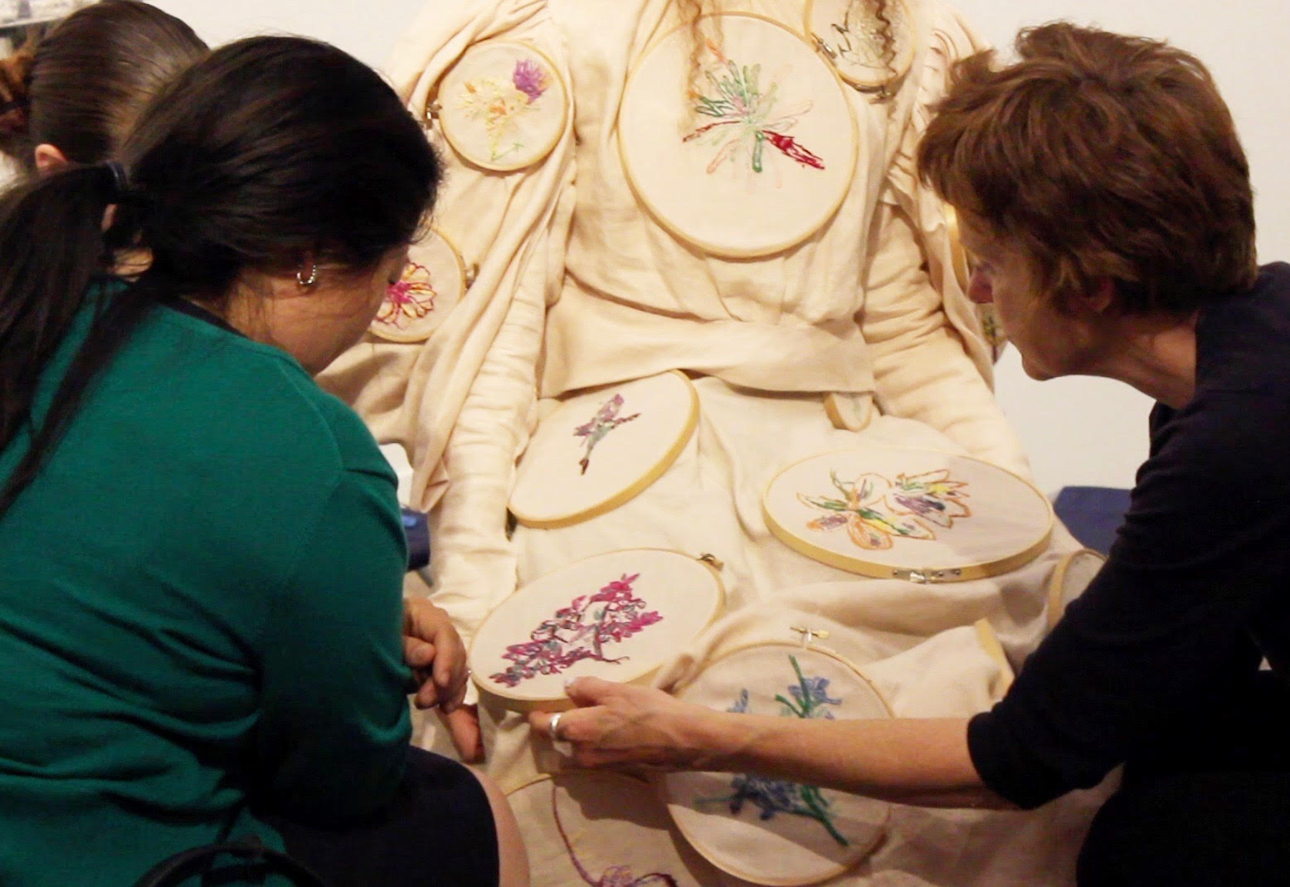
I am grateful to have had a lengthy residency, with 24/7 access to a studio, and a space to show work for three wonderful months. Bay Area artists can struggle to find an economic foothold, living space and time to work, so residencies like this can really enable artists to grow in their practice. The museum is supportive in this way. I loved having the audience that came through—they were so interested in process. A lot of them had no experience with textile processes before and it was great to have those conversations and connect with people. I learned things from them, they were learning from me. There was lots of resource and knowledge sharing!
Liz Harvey inviting First Friday visitors to sew on the lost ones

Your donation will help the Museum’s growth for the next forty years.

As the only arts institution in the Bay Area dedicated to fiber art, quilts and textiles, the San Jose Museum of Quilts & Textiles is crucial to preserving and honoring this medium. The Museum tracks a legacy of textile and art traditions and keeps them relevant for current and future generations.
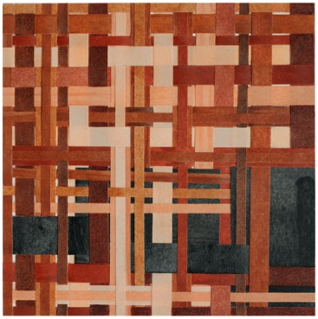
Pilar Agüero-Esparza, Skin Tone 5

Despite the tremendous entrepreneurial growth in Silicon Valley, artists and museums continue to find it challenging to live and work here. As this region grows and continues to expand, artists and the public need a space to appreciate and recognize textile art pieces as significant cultural objects.

By donating, you help ensure that fiber art, quilts and textiles are an integral part of the Bay Area community.

Your donation directly supports the artists in the Artist in Residence program as well as all of the artists who exhibit their work in over twenty exhibitions mounted each year.

In addition, your gift supports other programs the Museum offers, such as immersive school tours for K-12 students, free Community Days, an impressive exhibition program, and the Permanent Collection.

You can help the Museum continue to act as caretakers of these incredible works of art.

Please make your gift today and be as generous as you can.

Thank you,
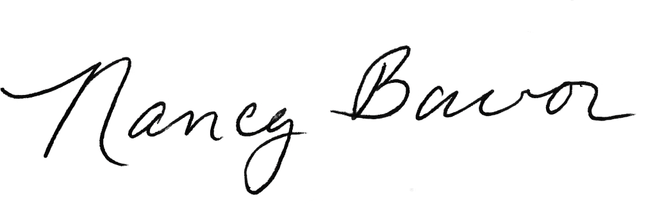
Nancy Bavor
Executive Director

P.S. Make a donation today to secure a place for fiber art in the Bay Area. Your support helps us celebrate the art, creators, and history of quilts and textiles.

